

| **Instructions for completing SEAP Funding Request Form** |
| --- |

1. Student Equity and Achievement Program (SEAP)funding requests for the **2024-2025** fiscal year are due: ***Monday, April 15, 2024***
2. An electronic copy of the completed request form with original signatures must be emailed to [seap@sac.edu](mailto:seap@sac.edu) and copy [miranda_cristina@sac.edu](mailto:miranda_cristina@sac.edu). Late, incomplete, or unsigned applications will not be processed. Hard copies will not be accepted.
3. Applicants are required to attend or view an **Equity Application Information Session**
   * Dates TBD
4. [**Equity Application Information Sessions**](https://us06web.zoom.us/rec/play/GCBJN6iCnmLJR7cYilXU_P2_EPaaroKmFakItsMJrVHYAItgrJYJnm-714JHRY4bvrB8zotsl-AXj0-P.VqAZU-YbR1Lf7-Tl?canPlayFromShare=true&from=share_recording_detail&continueMode=true&componentName=rec-play&originRequestUrl=https%3A%2F%2Fus06web.zoom.us%2Frec%2Fshare%2Fav71LWA-dsNHsySfeBkQGFM6drLfXXiji0bEbr14nRANw2twpVKTAuhkPBQYSt8.fXxfQ0TKNZjzId2I) **Recording**
5. **Required one-on-one session with the Research Department** must be scheduled directly with Dr. Martinez via email request to [martinez_danielN@sac.edu](mailto:martinez_danielN@sac.edu) to support the development of your program’s measurable outcomes, goals, and data strategy plan.
6. **Reminders:** Non-allowable expenditure requests that will not be considered:
   * Non-allowable expenditures as per the Expenditure Guidelines from the CCCCO Office:
     1. [Expenditure Guidelines](https://www.cccco.edu/-/media/CCCCO-Website/Files/Educational-Services-and-Support/SEAP/sea-expenditure-guidelines-a11y.pdf)
   * Gift Cards
   * Permanent or short-term salaries for faculty and classified staff
   * LHE for Faculty
   * Stipends for faculty, staff, and students
   * Food for faculty and staff
7. ***Requestors will be informed via email of the decision by Mid to Late May***.
8. The review committee reserves the right to request additional information if it is needed to decide on an award or to allocate funds.
9. Funds are to be used **only for the activities/expenses on this grant request**. Funds used for other activities/expenses are strictly forbidden without the expressed written consent of the Student Equity and Achievement Program Fund Review Committee or the Faculty Equity Coordinator and the Vice President of Academic Affairs.
10. All grantees will be required to submit an Impact Report after the first year of implementation, typically the Fall semester. A scanned/emailed copy of the completed Impact Report with original signatures must be emailed to [seap@sac.edu](mailto:seap@sac.edu). Due dates to be determined, grantees will be provided with more information closer to the due date.

| **Information on Categorical Programs** |
| --- |

1. [Principles of Guided Pathway at Santa Ana College](https://www.sac.edu/Pathways/Pages/default.aspx)
2. [2022-2025 Santa Ana College Equity Plan](https://drive.google.com/file/d/1OaYxtbPEFIivVotMOp47-0YjJlvK7KQa/view?usp=sharing)
3. [California Mandated Equity Groups](https://leginfo.legislature.ca.gov/faces/codes_displayText.xhtml?lawCode=EDC&division=7.&title=3.&part=48.&chapter=2.&article=1.5)

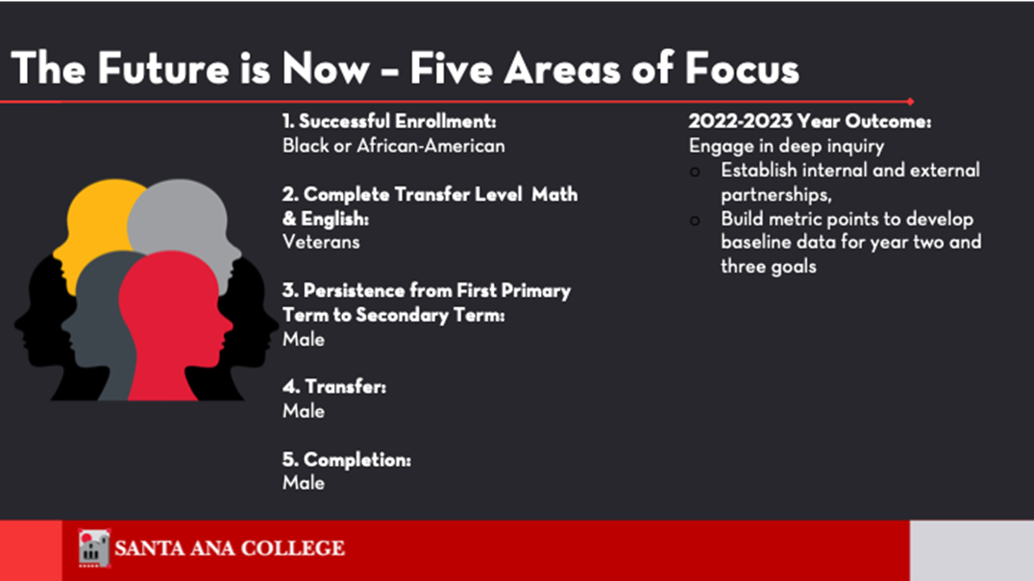

1. Year Two (2023-2024) target outcomes are focused on closing equity gaps as follows:

**Successful Enrollment**

**Student Focus:** Black, African American, African Diaspora

**Year Two-Target Outcome:** Engage in activities to increase enrollment of Black/African

American/African Diaspora students who successfully enroll from 26 to 34 students (eight students or 28.9% increase) or higher.

**Completed Transfer-Level Math & English**

**Student Focus:** Veterans

**Year Two-Target Outcome:** Engage in activities to complete Transfer-Level Math and English by Veteran students from one to two students (one student or 124.7% increase) or higher.

**Persistence: First Primary Term to Secondary Term**

**Student Focus:** Males (especially Black/African American)

**Year Two-Target Outcome:** Engage in activities to increase number of male students who persist from primary term to secondary term from 1150 to 1305 students (155 students or 13.5%) or higher.

**Transfer**

**Student Focus:** Males (especially Black/African American)

**Year Two-Target Outcome:** Engage in activities for male students to transfer to a four-year institution in three years from 126 to 146 students (20 students or 15.9% increase) or higher.

**CONTINUED:** Year Two (2023-2024) target outcomes are focused on closing equity gaps as follows:

**Completion**

**Student Focus:** Males (especially Black/African American)

**Year Two-Target Outcome:** Engage in activities for male students to attain the vision for success definition of completion within three years from 203 to 228 students (25 students or 12.5% increase)

*Populations detailed in Education Code 78220